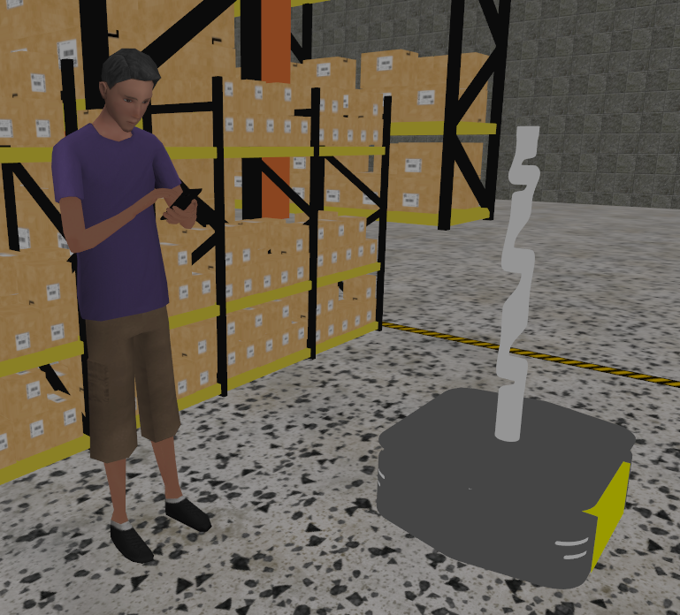
Client: École Nationale d’Ingénieurs de Tarbes
Group name: BOB
Date: 11-12-2025
Version: 4.0
Authors:
Jasper van Boven
Jelle Ramaker
Hyojun Choi
Leon Dewint
Krzysztof Koscielniak
Subject: European Project Semester
Make and test a Mobile-Robot for a Collaboration with Humans
Final Report

Summary
This project investigated the integration of two advanced robotic systems, the Kinova Gen3 manipulator arm and the Clearpath Ridgeback mobile platform into a unified, collaborative mobile manipulator using the ROS2 ecosystem. The work was carried out as part of the European Project Semester (EPS) at ENIT and combined both technical development and project management activities. From the outset, the team conducted a thorough analysis of the hardware, software, and project constraints to define a clear scope, objectives, and requirements.
Development began with preparing the working environment, installing Ubuntu, ROS2 Jazzy, simulation tools, and all required drivers. Extensive research and testing were performed to understand the communication structures of the two robots, identify compatibility challenges between ROS distributions, and design a setup that could reliably support both simulation and physical execution. With the Ridgeback temporarily out of service, simulation became a central focus of the work, allowing the team to model, test, and validate robot behaviours in Gazebo before applying them to the physical Kinova Gen3 arm.
A major technical accomplishment was the creation of a custom ROS2 trajectory-mirroring node. This node resolved differences in topic namespaces and joint naming conventions between the physical Kinova and its simulated counterpart, enabling synchronized motion across both systems. Alongside the simulation and control development, the team ensured proper documentation, risk monitoring, workload estimation, and milestone tracking—key components of the EPS methodology.
Throughout the project, iterative testing, supervisor feedback, and structured monitoring strengthened the clarity and reliability of the results. Despite encountering hardware failures, software instability, and scheduling challenges, the team achieved the essential objectives of Plan B. The final outcomes include a working simulation of a combined mobile manipulator, validated physical control of the Kinova arm, a complete set of UML diagrams, a detailed setup manual, and a coherent ROS2-based architecture ready for future expansion.
This project demonstrates the feasibility of integrating heterogeneous robotic systems and provides a solid foundation for future EPS teams who may extend the work toward complete real-world deployment, advanced navigation, sensor integration, and full autonomy.

Acknowledgements
We are thankful for the opportunity to participate in such exchange at ENIT, which has contributed to our academic and personal growth. We would like to especially express our sincere gratitude to the people who have supported and guided us through the preparation of this EPS project.
- Technical supervisors: Mourad Benoussaad and Thierry Louge
For their valuable technical guidance, constructive feedback and continuous support throughout the process of development project.
- EPS Coordinator: Mourad Benoussaad
For coordinating the project framework, ensuring smooth communication, and providing us with clear directions at each stage.
- Management supervisor: Khanh Nguyen
For her guidance in project management, team organization, and providing us with valuable insights on effective collaboration.
- International Relations Office: Karen Sautet
For her kind assistance in administrative and organizational matters, which made our arrival, work and stay at ENIT easier.
- EPS Project Management Teacher: Philippe Fillantreau
For the teaching and preparation of the bases for a streamlined and well-structured management part of the EPS project.
- Com & Team building EPS and TOEFL Teacher: Liz Chaigne
For the kind and well taught classes in preparation for team building and presenting during the EPS period and after.
- FLE teacher: Manuelle Denisse
For the basic teachings of the French language and making living in France a little bit more doable during the EPS period.

We would also like to extend our appreciation to all fellow students, International club and the whole ENIT community for their warm welcome and supportive environment.

Table of Contents
Summary 1
Acknowledgements 2
Table of Contents 3
List of Figures 4
List of Tables 5
Glossary 6
1. Introduction 7
1.1. European Project Semester 7
1.2. The Team 8
1.3. The logos and Team name 8
1.4. Supervisors 9
1.5. Client 9
2. Scope of the project 10
2.1. Problem Description 10
2.2. Main Objective 10
2.3. Deliverables 11
2.3.1. Technical Deliverables 11
2.3.2. EPS Deliverables 11
2.4. Requirements, Limits and Exclusions 12
2.4.1. Technical/project requirements 12
2.4.2. Switch plan 13
2.4.3. Limits and exclusions 13
3. Project Planning 14
3.1. Milestones 14
3.2. Risk Analysis 14
3.2.1. Project management risks 16
3.2.2. Preventive- and corrective actions 16
3.3. WBS 17
3.4. Workload estimation 18
3.5. Gantt diagram 21
3.6. Budget and cost estimation 21
4. Technical 22
4.1. Hardware study 22
4.1.1. UML Component diagram 22
4.1.2. Clearpath Ridgeback 23
4.1.3. Kinova Gen3 24
4.1.4. Central computing unit 25
4.2. Software study 26
4.2.1. Introduction of the used Software 27
4.2.2. Software deployment architecture 30
4.3. Development of the communication bridge between simulated and physical systems 31
4.4. Testing and validation 33
4.5. User documentation and operational guidelines 33
4.5.1. User Manual and System Setup Guide 33
4.5.2. Technical documentation of software architecture and issues 34
5. Monitoring 35
5.1. Workload monitoring 35
5.2. Evaluation of Project Requirements 36
5.3. Milestones Tracking and Completion Analysis 37
5.4. Observed Risks and Corrective Measures 38
6. Conclusions and discussion 39
6.1. Conclusion of the project 39
6.2. Future work 39
7. Appendixes 40
7.1. Appendix 1: References 40
7.2. Appendix 2: Bibliography 41
7.3. Appendix 3: WBS 42
7.4. Appendix 4: Gantt Chart 45
7.5. Appendix 5: Ros2 RQT Graph 49
7.6. Appendix 6: Total timetables 50

List of Figures
Figure 1: EPS logo 7
Figure 2: BOB logo 1 8
Figure 3: BOB logo 2 8
Figure 4: LGP Logo 9
Figure 5: UTTOP Logo 9
Figure 6: Risk matrix, the matrix is a template made by Vertex42 (Wittwer, 2024) 15
Figure 7: WBS Main branches 17
Figure 8: Technical development structure 22
Figure 9: UML Component diagram 23
Figure 10: Ridgeback by Clearpath Robotics 23
Figure 11: Kinova Gen3 manipulator 24
Figure 12: Nvidia Jetson Nano (Sheshadri, 2021) 25
Figure 13: The simulation in Gazebo, simulated Ridgeback and the Kinova Gen3 27
Figure 14: Ubuntu logo and code name 27
Figure 15: RViz2 Logo 28
Figure : Gazebo Harmonic Logo 28
Figure 17: RViz application with MoveIt plugin for motion planning 29
Figure 18: Clearpath Robotics logo 29
Figure 19: Kinova Logo 29
Figure 20: UML Deployment diagram 30
Figure 21: UML State diagram 31
Figure 22: Schematic overview developed ROS2 structure 32
Figure 23: Mirror_node code sample 32
Figure 24: Example of user guideline 34
Figure 25: Estimated workload of the project 35
Figure 26: Actual workload of the project 35
Figure 27: Total time spent per category 36
Figure 28: WBS EPS documents 42
Figure 29: WBS Technical part 43
Figure 30: WBS programs part 44
Figure 31: Gantt chart part 1 45
Figure 32: Gantt chart part 2 45
Figure 33: Gantt chart part 3 46
Figure 34: Gantt chart part 4 46
Figure 35: Gantt chart part 5 47
Figure 36: Gantt chart part 6 47
Figure 37: Gantt chard part 7 48
Figure 38: ROS2 RQT Graph (davetcoleman, 2018) 49

List of Tables
Table 1: Glossary 6
Table 2: The team 8
Table 3: Supervisors & Coordinator 9
Table 4: Technical deliverables 11
Table 5: EPS deliverables 11
Table 6: Technical Requirements 12
Table 7: Limits table 13
Table 8: Milestones 14
Table 9: Technical risks 15
Table 10: Project management risks 16
Table 11: Preventive and corrective actions 16
Table 12: Workload estimation 18
Table 13: Workload per team member 20
Table 14: Used software 26
Table 15: ROS2 versions 28
Table 16: Requirements qualification 36
Table 17: Milestone monitoring 37
Table 18: Referenced documentation 40
Table 19: Total time spend per category of work 50

Glossary
Table 1: Glossary
No. | Term | Definition
1 | ENIT | École Nationale d’Ingénieurs de Tarbes
2 | UTTOP | Université de Technologie Tarbes Occitanie Pyrénées
3 | EPS | European Project Semester
4 | LGP | Laboratoire Génie de production
5 | AGV | Automated Guided Vehicle
6 | ROS | Robot Operating System
7 | ECTS | European Credit Transfer and Accumulation System
8 | SMART | Specific, Measurable, Achievable, Realist, Time-bound
9 | Cobot | Collaborative Robot
10 | ECTS | European Credit Transfer and Accumulation System
11 | WBS | Work Breakdown Structure
12 | Raspberry Pi | A small computer
13 | Open Source | An engineering project that has all their resources open for everyone to edit and use
14 | OS | Operating System, like Microsoft Windows or Apple IOS
15 | GUI | Graphical User Interface, for example a screen
16 | UML | Unified Modelling Language

Introduction
This project is made for the European Project Semester, and is about the communication between two collaborative robots, which will be done through ROS. This means that communication between two collaborative robots is the process of transmitting and receiving information through a defined protocol or medium, enabling them to synchronize operations, avoid conflicts, and achieve joint objectives within a shared workspace.

Figure 1: EPS logo

European Project Semester
The European Project Semester, or EPS for short, is a collaboration between different European universities. It is given in 20 academic institutions. The projects differ from university to university, but they all have the duration of a semester and after successful completion of the project the student will get 30 ECTS. Every school has their differences during the semester in which different courses are given. But they have all agreed about curtain key elements, dubbed the 10 golden rules: (European Project Semester, n.d.)
- Semester lasts 15 weeks minimum
- EPS is project centred
- Working language is English
- 30 ECTS per semester are offered in total, whereof the project covers min. 20 ECTS, accompanying subjects 5 to 10
- Accompanying subjects must support the project subject English and a basic crash course in the local language must be an option.
- Subjects include Teambuilding and Project Management
- Project groups are composed multinational, group size 3-6 students, min. 3 nationalities multi disciplinarily desired.
- Focus on EPS is teamwork
- Project supervision focuses on the process as well as the product
- EPS must have continuous assessment including an interim report and a final report

The Team
The project will be made by a team consisting of five international students all with different backgrounds, skills and ideas. This team will be making the documentation and research the possibilities withing the scope of the project.
Table 2: The team
Leon Dewint | Jasper van Boven | Jelle Ramaker | Hyojun Choi | Krzysztof Koscielniak
   |    | 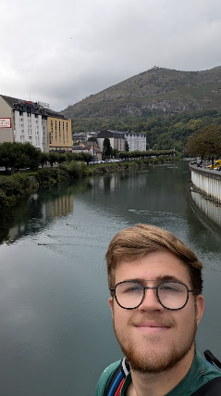   |    | 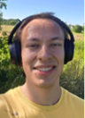  
AP Hogeschool | Avans University of applied science | Avans University of applied science | Korea University of Technology and Education | University of Silesia
Bachelor in  industrial automation | Bachelor in mechanical engineering | Bachelor in electrical engineering | Bachelor in mechanical engineering | Bachelor in biomedical engineering
leon.dewint@etudiant.uttop.fr | jasper.van_boven@etudiant.uttop.fr | Jelle_gerrit.ramaker@etudiant.uttop.fr | hyojun.choi@etudiant.uttop.fr | krzysztof.koscielniak@etudiant.uttop.fr

The logos and Team name
As a project group we have designed two logos and came up with a team name for the documents to make the whole project more personal and give the project a personal touch.
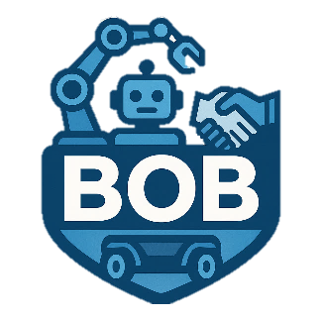
To start the Team name. The team is called ‘Team BOB’, which stands for ‘Bot on Bot’. The name was chosen because of the core and in a fun way the project is aimed to put a robot on top of another robot. So that is how the team name ‘Team BOB’ came into existence.
Figure 2: BOB logo 1
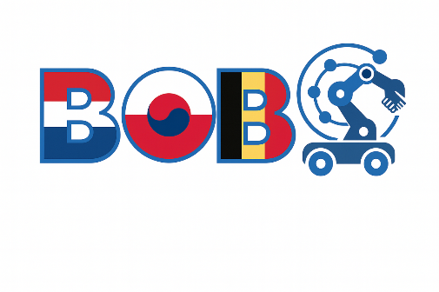
The two logos have the same idea. The team’s name is mentioned in both logos and stands out. The difference between the two is the size and simplicity. The logo in Figure 2: BOB logo 1 is a simple logo showing out team name and suggest the collaboration between two robots with the figures and shapes. This logo will be used as a header logo in the documents. The logo in Figure 3: BOB logo 2 is the big logo used for the frontpage of all out documents. This logo is, again, the team’s name. But not it is filled with the country flags of the individual team members. Paired with two robots on top of each other hinting to the project.
Figure 3: BOB logo 2

Supervisors
The project is supported by different teachers and professors. They are technical supervisors and a project management supervisor. They will help with the organisation of the project and check any documentation. They are also available for any technical questions and can offer support here.
Table 3: Supervisors & Coordinator
Technical Supervisors | Email
Thierry Louge | thierry.louge@uttop.fr
Mourad Benoussaad | mourad.benoussaad@uttop.fr
Management supervisor
Khanh Nguyen | thi-phuong-khanh.nguyen@uttop.fr
EPS Coordinator
Mourad Benoussaad | eps-responsable@enit.uttop.fr

Client
- UTTOP
Engineering school, official stakeholder associated with LGP laboratory. Provider of EPS.
- LGP
Research laboratory partnered with UTTOP, supporting applied research in robotics, automation and industrial engineering.

Figure 4: LGP Logo

Figure 5: UTTOP Logo

Scope of the project
This section outlines the overall scope of the project, starting with the description of the problem that needs to be addressed. It then defines the main objective of the work, followed by the expected deliverables. Finally, the requirements, limitations, and exclusions are presented to clarify the project boundaries and ensure a shared understanding among all stakeholders.

Problem Description
The project addresses the challenge of integrating two distinct robotic systems: the Kinova Gen3 manipulator arm (Kinova Robotics, sd) and the Ridgeback mobile AGV (Clearpath Robotics, sd) see chapter 4.1. While each robot can perform specialized tasks independently, their combined operation has the potential to create a versatile mobile manipulator. Achieving this requires the development of a communication framework that allows both systems to function as one.
To facilitate this integration the Robot Operating System (ROS) is used (Open Robotics, sd). This is because both the Kinova and the Ridgeback robots are using a distribution of ROS, for further explanation on ROS see chapter 0. However, the absence of prior experience of the technical supervisors with ROS at UTTOP introduces an additional layer of complexity, as the project team must acquire, adapt and implement this knowledge while ensuring that the integration meets both functional and technical requirements.

Main Objective
The primary objective of this project is to develop and implement a communications framework that enables the Kinova Gen3 manipulator arm and the Ridgeback Mobile Robot to operate as one robot. This is to do movements and operations simultaneously and from one interface so both robots will move like one. This communication will be established using the software ROS and other software’s necessary to realise the connection. To execute a dedicated computing unit, Jetson-Nano see chapter 4.1, will be used with all the functionalities first validated in a simulation and certain parts in real-world environment.
Due to the Ridgeback Mobile Robot not being functional, because of a faulty battery and a replacement battery being months away from arriving, simulation software will be used to test the communication framework. The Kinova Gen3 manipulator arm however is functional and will be tested physically and virtually to validate the connection between both the robots.
To ensure clarity and feasibility, the objective is defined according to SMART criteria:
- Specific: The Kinova Gen3 manipulator Arm and the Ridgeback Mobile Robot will be connected through a ROS based interface and tested in a virtual environment. This will result in a virtual manipulator robot consisting of both robots. Besides the virtual environment the Kinova Gen3 will be tested in a physical environment to validate the virtual movements.
- Measurable: The combined system virtual/simulation and the physical Kinova Gen3 will have a delay less than 5 milliseconds [ms] between each other.
- Achievable: The project is feasible using available laboratory resources and technical expertise. Clearly defines roles and responsibilities allow for effective task allocation within the team.
- Relevant: As part of the ECOSYSPRO program at UTTOP, see chapter 7.1 R2 for further information
- Time-bound: The project is constrained by fixed deadlines like an intermediate presentation and report with a submission on 9 October 2025.

Deliverables
This section outlines the concrete outcomes that will be produced and delivered at the end of the project. The deliverables are divided into two categories: technical deliverables, which represent the functional and design outputs directly related to the integration of the robotic systems, and EPS deliverables, which consist of the required documentation and presentations for the European Project Semester. Together, these deliverables define the tangible results that both the client and academic supervisors can expect from the project.

Technical Deliverables
The technical deliverables are the deliverables that are project oriented. These deliverables will be for the technical supervisors and are for design and the actual working order of the objective. They are given to our technical supervisor Thierry Louge on a USB stick.
Table 4: Technical deliverables
Name | Explanation
UML Activity diagram | This diagram describes the custom code written with sequential actions.
UML Deployment diagram | This diagram is used to describe all the used hardware components and how they are connected.
UML Component diagram | This diagram is used to describe all the used software, where they are installed and how they are connected to each other.
Technical requirements | These are the requirements the project must comply with on a technical level.
Manual | This document should tell a new user how to use to robot software for the first time.
ROS node diagram | This diagram shows all the nodes of the ROS diagram. What these are is explained in chapter 0
Working communication | A functional ROS stack to control both robots at the same time.
Controlling Terminal | An interface to control the robots through a terminal, with small easy commands.
Working simulation | Both robots fully functional in Gazebo Simulation Software.

EPS Deliverables
EPS deliverables are the mandatory outputs for the EPS in form of documentation. EPS deliverables will be presented as settled goals and final achieved outputs.
Table 5: EPS deliverables
Type | Explanation
Intermediate report | Mid-term document that defines the stakeholders, final plan for project and its limitations
Intermediate presentation | Document to be presented in front of jury that shows both technical and managing aspects
Project requirements | Project planning details (project management, scope of the project)
Final report | Final document that describes whole done work for project
Final presentation | Final presentation to be shown in front of jury to share achieved results of project

Requirements, Limits and Exclusions
This section defines requirements of project, as well as its main constrains and exclusions. It specifies what is needed to achieve, and what is explicitly outside the project scope.

Technical/project requirements
The requirements are made to encompass all the client’s needs and expectations for this project. They serve as guidelines while making the project. This way both the client and team members know what is expected to result from this project.
There are two plans, A and B. Plan A is the main objective, these requirements will be the focus of the project. Plan B will be a reduction of what plan A will contain when deadlines won’t be met.
Table 6: Technical Requirements
Nr. | Title of requirements | Explanation
1.1 | Integrating existing code | Integrating and adopting an existing code for the Kinova Gen3 Manipulator arm.
1.2 | The system of ROS will be used | The connection between the robots will be controlled by the system ROS. This is because both robots have a ROS – version installed on the drivers.
1.3 | The simulation contains 2 separate robots. | The simulation will contain the Kinova Gen3 manipulator arm and the Ridgeback mobile robot as the two separate robots that will make a new system
1.4 | Compatibility research ROS distributions. | Different distributions of ROS need to communicate together, because the robots have different versions of it. The “how” of this will be needed to be researched.
1.5 | Real world physical testing Kinova Gen3 manipulator arm | The Kinova Gen3 manipulator arm, which is in working order, will move in the real world controlled by a ROS diagram on a central computing unit
1.6 | Typical use case for proof of integration | In the end a typical use case, think about a pick and place movement while moving from A to B, will be shown where the two robots work together and move as one robot (The Kinova is moving and the Ridgeback is driving) to proof the working of the integration.
1.7 | Simulation environment for testing and validation | A simulation platform, Gazebo, will be implemented to model and test the integration between the Kinova Gen3 manipulator arm and the Ridgeback mobile robot. Simulation allows for validation of communication of functionality in a sage, cost-efficient environment before deployment on a physical robot
1.8 | Extra robot for real world validation with the Pioneer LX | To validate the real-world movement of both robots at the same time as one robot a different robot, the Pioneer LX. This will validate and show the flexibility of the ROS system.
1.9 | Physical testing Ridgeback mobile robot. | When the Ridgeback is in working order, the robot will be used and tested using the created ROS diagrams and programs to validate these.
1.10 | Central computing unit for robot integration | A central computing unit (e.g., Raspberry Pi of equivalent) with a host ROS framework can act as the control hub, instead of a laptop. It will be managing communication between the Kinova Gen3 manipulator arm and the Ridgeback Mobile Robot, ensuring synchronization and coordinated operation.

Plan A contains all the requirements listed in Table 6. This contains all the requirements listed in Table 6, with an exception for requirement 1.8, 1.9 and 1.10. These requirements are for an ideal circumstance where everything goes as planned.
Plan B contains all the requirements that are important to finish the project in a stable state when there are difficulties during the project and when unforeseen happenings occur. During the project the unforeseen things have happened.

Switch plan
The decision was made to switch to plan B. that means requirements 1.8, 1.9 and 1.10 are dropped and will not be worked out to finish the project in a stable state. The decision has been made due to different reasons. Requirement 1.8 has been dropped due to time concerns. Requirement 1.9 has been dropped due to that the Ridgeback mobile robot still is not in working order. And requirement 1.10 has been dropped due to compatibility issues of the central computing unit and the available robots.

Limits and exclusions
This section defines the boundaries of the project by specifying what will not be undertaken and clarifying the limitations of certain tasks. Establishing these exclusions helps to maintain focus on the core objectives and ensures that expectations regarding the project outcomes are realistic. The identified limits are summarized in Table 7.
Table 7: Limits table
Nr. | Title | Explanation
1. | No mechanical design | There will not be anything designed in a physical form, like a mount for the Kinova robot on the AGV.
2. | No changes in/on robots | The robots contain code and drivers. These codes won't get touched to keep the robots original. Also, no additions will be made to the robots, again to keep the robots as original as possible.
3. | Limits “Typical use case” | The use case will only be presented with a digital robot, the Kinova Gen3 on top of the Ridgeback, and the physical Kinova Gen3. There will be no fully functional physical robot with the Kinova Gen3 on top of the Ridgeback.
4. | No physical testing on ridgeback AGV | There will be no testing the physical Ridgeback Mobile Robot. The typical use case will only be performed in a simulation software on the laptop.
5. | No gripper | No gripper/ hand will be simulated or physically used.
6 | No sensors | The Ridgeback has a sensor build in for special awareness. This sensor can be disregarded when making the virtual environment

Project Planning
Project planning presents organization and time management aspects of the project. It describes how the tasks were structured, prioritized, and scheduled to ensure an efficient workflow.

Milestones
Milestones represent key points within the project timeline. Each milestone has its own date to be executed, and it marks completion of important task, such as report submission or achievement simulation report.
Table 8: Milestones
Nr. | Date | Milestone
M1 | 01/09/2025 | Project start
M2 | 09/10/2025 | Submission of intermediate report and technical requirements
M3 | 16/10/2025 | Intermediate presentation
M4 | 14/11/2025 | Software simulation for Kinova
M5 | 17/11/2025 | Physical testing for Kinova
M6 | 21/11/2025 | Software simulation for Ridgeback
M7 | 11/12/2025 | Combining both robots in software simulation
M8 | 11/12/2025 | Submission of final report
M9 | 18/12/2025 | Final presentation

Risk Analysis
This section identifies and evaluates the potential risks that could impact the progress and outcome of the project. The risks are divided into two main categories: technical risks, which relate to the software. hardware, and system integration aspects, and project management risks, which concern organizational and human factors. Each risk is assessed in terms of likelihood and impact, resulting in a risk level classification. Based on this analysis, preventive and corrective actions are proposed to minimize their influence on the project timeline and deliverables.
To support the assessment, a risk matrix has been developed. The matrix visualizes how likelihood and impact combine to determine the overall risk level, which guides the prioritization of mitigation strategies.
Figure 6: Risk matrix, the matrix is a template made by Vertex42 (Wittwer, 2024)
The technical risks identify potential technical challenges that may occur during the development of the project. Likelihood shows possibility of happening, and impact shows how great the consequences can be.
Table 9: Technical risks
Nr. | Title | Explanation | Likelihood | Impact | Risk Level
TR 1 | ROS2 distributions not being compatible | Due to there being multiple ROS types being used, there is a change of them not being compatible | 3 | 5 | 15
TR 2 | Losing data | There is a risk of losing important data during crashes, updates or mistakes. | 2 | 5 | 10
TR 3 | ROS2 Rolling instability | ROS2 Rolling is unstable. It changes often because it is not an LTS (Long-Term-support) version. These changes can make problems with compatibility or stop some functions from working. | 2 | 4 | 8
TR 4 | Network problems | If network is slow or not working, the team can’t test or connect to the robot. | 5 | 2 | 10
TR 5 | Mechanical Failure | When a robot malfunctions and stops work on it. | 2 | 3 | 6
TR 6 | Hardware failure Raspberry Pi | A hardware mistake that ruins the Raspberry Pi. | 1 | 3 | 3
TR 7 | Hardware not strong enough | The Raspberry Pi not having enough computational power to run both robots at the same time. | 2 | 3 | 6
TR 8 | Cable failure | A break in a cable which stops power or communication. This might be hard to find. | 2 | 4 | 8
TR 9 | Network Connectivity problems | Not able to connect to the Raspberry Pi and or robots and or between robots. | 2 | 3 | 6

Project management risks
Project management risks focus on non-technical risks related to the organisation, communication and resource management. Likelihood shows possibility of happening, and impact shows how great the consequences can be.
Table 10: Project management risks
Nr. | Title | Explanation | Likelihood | Impact | Risk Level
PR 1 | Sport accident | Injuries caused during sport activity that will prevent member from teamwork | 2 | 2 | 4
PR 2 | Car accident | Traffic accident that will prevent member from teamwork | 2 | 4 | 8
PR 3 | Sickness | Temporary loss part of team due to sickness | 3 | 3 | 9
PR 4 | Schedule conflicts | Difficulty with meeting technical supervisors and project manager | 3 | 3 | 9
PR 5 | Time limit | Strict deadline with no margin for delay | 1 | 3 | 3

Preventive- and corrective actions
For each identified risk, measures are defined either to reduce the likelihood of occurrence (preventive actions) or to limit the impact if the risk materializes (corrective action). These actions are presented in Table 11, which links each risk to its corresponding mitigation strategy.
All identified risks should at least be recorded and monitored, even if their level is low. However, the low risks (1–6) normally need to be monitored, no need for formal actions unless easy/low-cost. Preventive and corrective actions are generally prioritized for medium to high risks, since addressing every minor risk can be inefficient.
Table 11: Preventive and corrective actions
Nr. | Title | Risk Level | Preventive action | Corrective actions
TR 1 | ROS2 distributions not being compatible | 15 | Do research on how the ROS2 distributions work and may work together | Doing research
TR 2 | Losing data | 10 | Making copies of documents and programs on multiple storage mediums. | Asses the point of data loss and take measures to prevent it from happening again.
TR 4 | Network problems | 10 | Not using Wi-Fi but connecting directly to the system. | Downloading large documents at home.
PR 3 | Sickness | 9 | None | When sickness occurs, ask what task can be done from home and help and support.
PR 4 | Schedule conflicts | 9 | Make and online space where feedback can be given on the documents and be reviewed by the designated people. | Try to reschedule at a different date with hard deadlines and with consequences if those meetings and deadlines are not met.
TR 3 | ROS2 Rolling instability | 8 | Load an older and stable version of ROS. | Note the bugs with the Rolling community so they can be fixed in the next version.
TR 8 | Cable failure | 8 | Do not bend and put the cable through tight corners and spaced. | Buy a new cable and try to avoid putting the cable through the same bends and corners as the cable before.
PR 2 | Car accident | 8 | Drive safely over the roads and prevent unsafe situations | Mourn and keep working. Besides, re-evaluate the workload of the team member that was in the accident

WBS
The Work Break Down structure can be found in Appendix 3: WBS. It has been made based on the deliverables and from the top down. The three main branches, which can be found in Figure 7, are EPS documents, Needed programs and robot programming. The EPS documents are separated into intermediate and final documents. The second branch for the needed programs requires some extra explanation, this branch add to the final product in a special way. These programs are namely used for the project, but they need more time as they are new programs in an unknown OS. The last branch is for the technical deliverables. In this branch the product is made and the programming is done.

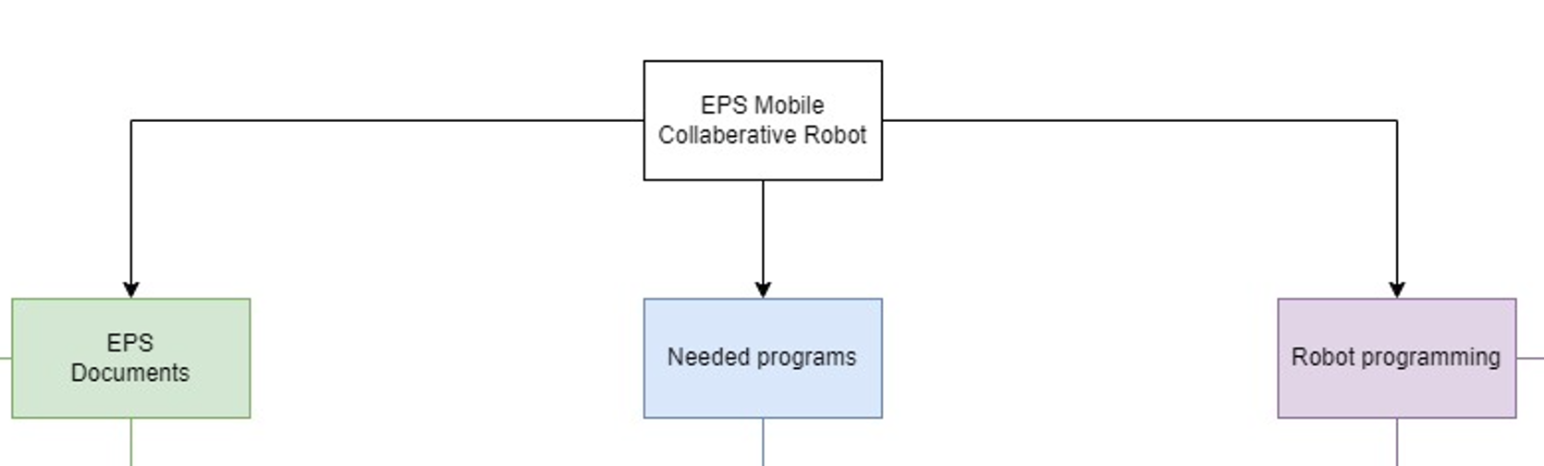
Figure 7: WBS Main branches

Workload estimation
In this chapter the workload is estimated according to all the tasks in the WBS. The names of the assigned stakeholders are shortened as follows: Hyojun Choi = C, Leon Dewint = L, Krzysztof Koscielniak = K, Jasper van Boven = JB and Jelle Ramaker = JR. The duration of each task will be noted in hours. To make sure the total work hours are not exceeded.
Table 12: Workload estimation
WBS Nr. | Title | Responsible | Workload [h] | Resources
D1 | EPS Documents
D1.1 | Intermediate documents
D1.1 | Intermediate report
D1.1.1 | Technical overview |  |  | C, K, L, JB, JR
T1.1.1.1 | Document used software | C | 2 | C, K
T1.1.1.2 | Make UML component diagram | JR | 12 | JR
T1.1.1.3 | Make UML deployment diagram | JR | 12 | JR
T1.1.1.4 | Make UML activity diagram | JR | 12 | JR
D1.1.2 | Project planning |  |  | C, K, L, JB, JR
T1.1.2.1 | Note the milestones | K | 3 | K
T1.1.2.2 | Create the risk analysis | JB | 3 | C, K, JB
T1.1.2.3 | Create WBS | JR | 6 | JR
T1.1.2.4 | Create GANTT diagram | L | 6 | L
T1.1.2.5 | Create costs overview | K | 0.5 | K
D1.1.3 | Scope of project |  |  | K, L, JB, JR
T1.1.3.1 | Describe the introduction | L | 3 | L, JR
T1.1.3.2 | Describe the problem | L | 3 | L, JB
T1.1.3.3 | Describe the objective | JB | 3 | C, JB, JR
T1.1.3.4 | Note the deliverables | K | 3 | K, L
T1.1.3.5 | Describe the requirements, limits and exclusions | L | 6 | K, L
D1.2 | Technical Requirements
T1.2.1 | Write the project requirements | L | 6 | C, L, JB
T1.2.2 | Write the technical requirements | L | 12 | L, JB
D1.3 | Intermediate Presentation
T1.3.1 | Create format | JB | 1 | JB
T1.3.2 | Create project management slides | JB | 3 | K, JB
T1.3.3 | Create project objective slides | K | 3 | K, JB
T1.3.4 | Create technical slides | L | 3 | L, JB
T1.3.5 | Train the presentation | JR | 6 | C, K, L, JB, JR
D1.2 | Final Documents
D1.2.1 | Project report document
D1.2.1.1 | Technical overview |  |  | C, K, L, JB, JR
T1.2.1.1.1 | Update UML diagrams | JR | 1 | JR
T1.2.1.1.2 | Update used software | C | 0.5 | C, K
T1.2.1.1.3 | Document final project state | JB | 3 | JB
D1.2.1.2 | Project planning |  |  | C, K, L, JB, JR
T1.2.1.2.1 | Create qualification requirements | L | 1.5 | L, JB
T1.2.1.2.2 | Do qualification of project | JR | 1.5 | L, JB
T1.2.1.2.3 | Document logbook | JR | 0.5 | C, K, L, JB, JR
T1.2.1.2.4 | Document MS Project | JB | 0.5 | JB
D1.2.1.3 | Scope of project |  |  | C, K, JB
T1.2.1.3.1 | Create project conclusion | C | 1 | J
D1.2.2 | Presentation
T1.2.2.1 | Create format | JB | 1 | JB
T1.2.2.2 | Create project management slides | JB | 3 | K, JB
T1.2.2.3 | Create project objective slides | K | 3 | K, JB
T1.2.2.4 | Create technical slides | L | 3 | L, JB
T1.2.2.5 | Train the presentation | JR | 6 | C, K, L, JB, JR
D2 | Preparation of working environment
D2.1 | Installed software
T2.1.1 | Install Ubuntu OS | L | 1 | C, K, L, JB, JR
T2.1.2 | Install robot control software | C | 3 | C, K, L, JB, JR
T2.1.3 | Install robot simulation software | C | 3 | C, K, L, JB, JR
D2.2 | Learning installed software
T2.2.1 | Learn Ubuntu OS | L | 3 | C, K, L, JB, JR
T2.2.2 | Learn robot control software | C | 3 | C, K, L, JB, JR
T2.2.3 | Learn robot simulation software | C | 3 | C, K, L, JB, JR
D3 | Robot programming
D3.1 | Ridgeback robot
D3.1.1 | Ridgeback simulation control
T3.1.1.1 | Manual robot control through ROS | JR | 60 | JB, JR
T3.1.1.2 | Robot control through terminal | JR | 12 | JB, JR
T3.1.1.3 | Robot control through short commands | JR | 6 | JB, JR
D3.1.1 | Ridgeback simulation visualisation
T3.1.1.1 | Load visual ridgeback | JB | 6 | JB, JR
T3.1.1.2 | Manual control of simulated robot | JB | 6 | JB, JR
T3.1.1.3 | Download robot drivers | JR | 0.5 | JB, JR
D3.2 | Kinova robot
D3.2.1 | Kinova physical control
T3.2.1.1 | Manual robot control through ROS | C | 24 | C, K, L
T3.2.1.2 | Robot control through terminal | L | 6 | C, K, L
T3.2.1.3 | Robot control through short commands | L | 3 | C, K, L
D3.2.2 | Kinova simulation control
T3.2.2.1 | Test if physical software works with simulation | K | 30 | C, K, L
T3.2.2.2 | Manual robot control through ROS | K | 12 | C, K, L
T3.2.2.3 | Robot control through terminal | L | 12 | C, K, L
T3.2.2.4 | Robot control through short commands | L | 12 | C, K, L
D3.2.3 | Kinova simulation visualisation
T3.2.3.1 | Load visual Kinova gen3 | K | 18 | C, K, L
T3.2.3.2 | Manual control of simulated robot | C | 18 | C, K, L
T3.2.3.3 | Download robot drivers | L | 0.5 | C, K, L
D3.3 | Combining Robots
D3.3.1 | Combination simulation control
T3.3.1.1 | Load visual ridgeback | JR | 3 | JB, JR
T3.3.1.2 | Load visual Kinova gen3 | C | 3 | C, K, L
T3.3.1.3 | Set Kinova robot on ridgeback robot | JB | 12 | C, JB
T3.3.1.4 | Manual control of both simulated robots | C | 12 | C, K, L, JB, JR
D3.3.2 | Combination simulation visualisation
T3.3.2.1 | Manual combined control | C | 12 | C, JB
T3.3.2.2 | Combined control through terminal | L | 18 | C, K, L, JB, JR
T3.3.2.3 | Combined control through short commands | JR | 12 | C, K, L, JB, JR
D3.3.3 | Combination simulation and physical control
T3.3.3.1 | Test if simulated software works with physical | K | 18 | C, K, L, JB, JR
T3.3.3.2 | Manual combined control | L | 6 | C, K, L, JB, JR
T3.3.3.3 | Combined control through terminal | JR | 12 | C, K, L, JB, JR
T3.3.3.4 | Combined control through short commands | JR | 6 | C, K, L, JB, JR

Table 13: Workload per team member
Team member | Workload [h]
Hyojun Choi | 295
Leon Dewint | 305
Krzysztof Koscielniak | 284
Jasper van Boven | 283
Jelle Ramaker | 267

Gantt diagram
The Gantt diagram provides a visual representation of the project schedule. It shows the distribution of tasks over time, their duration, dependencies, and overlap. Main goal of Gantt is to monitor progress and maintain deadlines. The task found in the Gantt diagram are taken from the WBS. The complete diagram can be found in Appendix 4: Gantt Chart.

Budget and cost estimation
There is no given budget for this project, but if a component is needed then it can be ordered after discussing this with the technical supervisors. All the software is open source and therefore free.
Estimated costs counted for human resources are calculated based on the involvement of team members and supervisors throughout the project duration. Assuming 5 student team members, each contributing approximately 260 hours of work at count of €15 per hour, the total cost would be:
- Students: 5 × 260 h × €25/h = €32,500
- Technical supervisors: 2 × 20 h × €45/h = €1,800
- Project manager: 1 × 10 h × €45/h = €450
Total estimated cost: €34,750

Technical
This section presents the complete technical workflow followed during the project, progressing from foundational analysis toward system implementation and validation. The work began with a hardware study, examining the Ridgeback platform, Kinova Gen3 manipulator, and the intended central computing unit to establish system constraints and communication capabilities. Building on this, a software study was conducted to prepare the operational environment, including Ubuntu, ROS2, RViz2, MoveIt2, and Gazebo. With both the hardware and software foundations defined, the project advanced to the development phase, where the communication bridge enabling synchronized control between the simulated and physical robots was designed and implemented. The resulting system was then subjected to testing and validation to verify functional performance and ensure reliable behaviour across simulation and real-world scenarios. Finally, the section concludes with user guidelines, providing a structured manual and technical report to support future use, replication, and further development of the system.
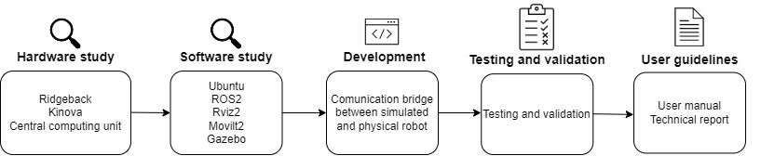
Figure 8: Technical development structure

Hardware study
This subsection provides a structured examination of all hardware components that form the foundation of the integrated robotic system. It begins with the presentation of the UML Component Diagram. This diagram outlines the structural organization of the system and clarifies how the main computing modules (the Ridgeback platform, the Kinova Gen3 manipulator, and the external control workstation) interact through ROS2. Following this architectural overview, the hardware study examines each component in detail. First, the Ridgeback mobile robot is described in terms of its mechanical characteristics, capabilities, and role as the base platform within the envisioned mobile manipulator. Next, the Kinova Gen3 arm is analysed, focusing on its degrees of freedom, communication interfaces, and suitability for collaborative manipulation tasks. The subsection concludes with a discussion of the intended central computing unit, addressing its planned function in the system and the compatibility limitations encountered during implementation. Together, these elements provide the hardware foundation needed for the software study and subsequent development work.

UML Component diagram
This diagram describes the structural organization of the system in terms of software components and their interfaces. It helps visualize how different computing modules communicate with ROS and are set-up together. The three main components: Ridgeback robot, Kinova Gen3 robot and laptop, are in here. Also, it represents what application runs on what hardware.
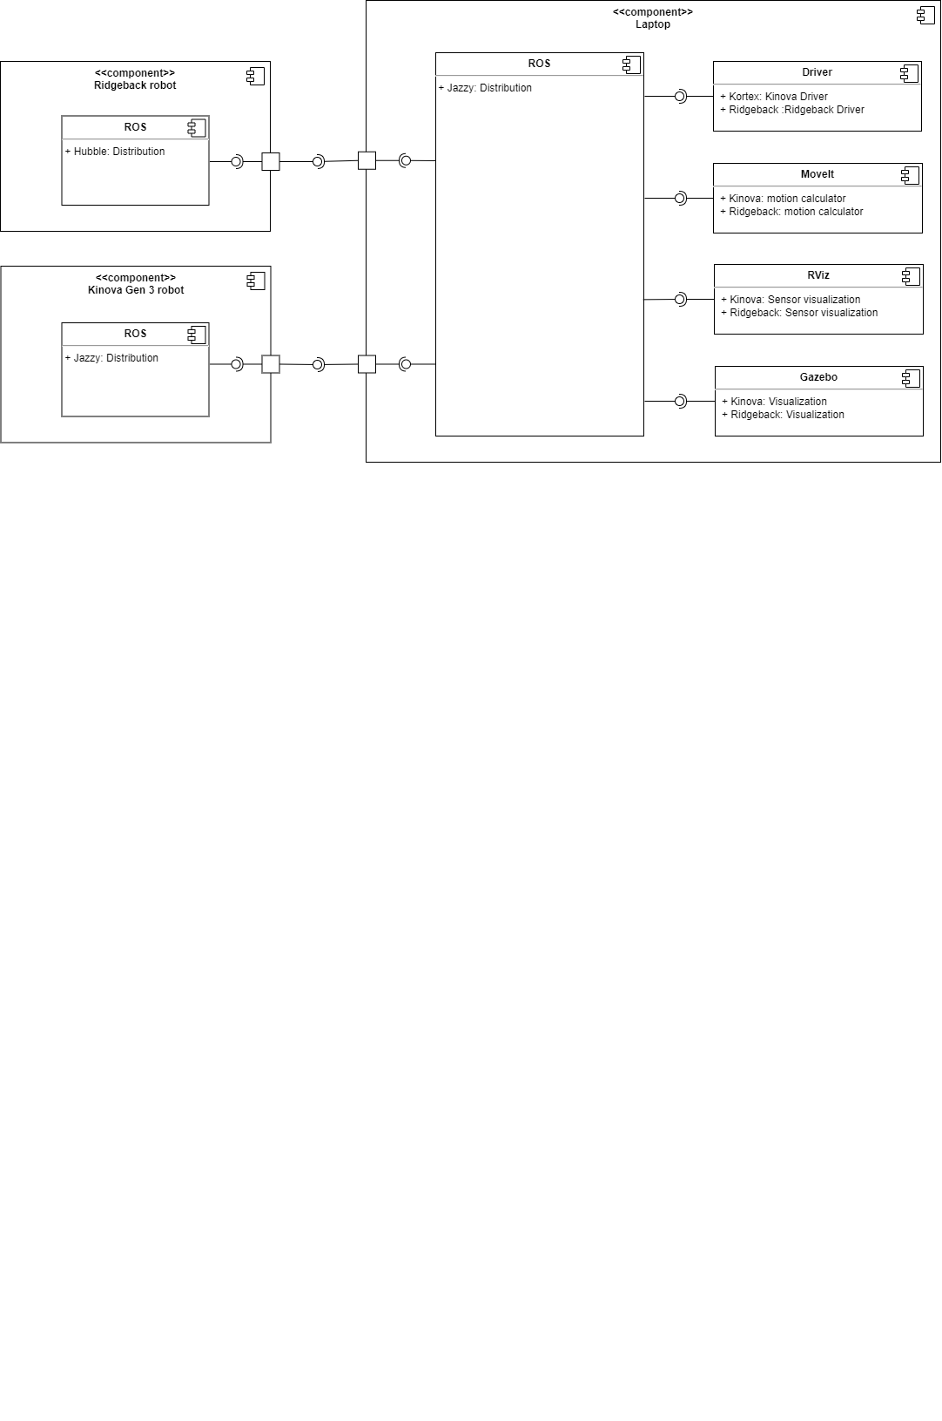
Figure 9: UML Component diagram

Clearpath Ridgeback
Ridgeback is an omnidirectional indoor mobile robot platform, which means it can move in any direction without needing to turn first. It can drive forward, backward, sideways, diagonally, and rotate in place. It is designed to carry heavy payloads on its top such as robot manipulators. It works together with ROS which makes it easier to control and program. Clearpath Robotics, developer of Ridgeback, provides it with ready demo Gazebo simulation and drivers compatible with ROS 2 Jazzy. An important note for this robot is the fact that is currently not functional, the repair of the robot and or ordering parts for it is outside of the scope for this project.
Hardware specifications:
- Dimensions: 96 x 79,3 x 31,1 cm
- Weight: 135kg
- Max payload: 100kg
- Communication: Ethernet
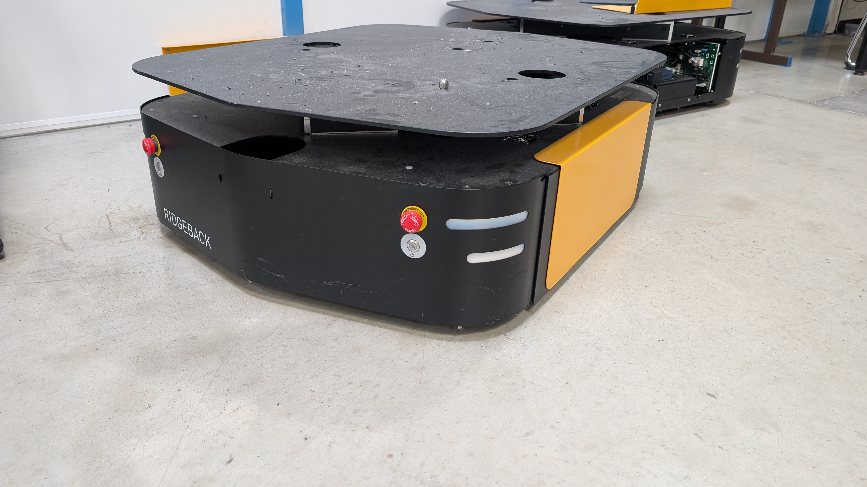
Figure 10: Ridgeback by Clearpath Robotics

Kinova Gen3
Kinova gen 3 arm is a robot manipulator with 7 degrees of freedom, designed for research, education and collaborative applications. Because it has 7 DOF, the arm is highly flexible and can reach targets from different angles while avoiding obstacles. It is commonly used in mobile manipulation, human–robot interaction, and computer vision research. The arm is equipped with integrated motors, force sensing, and low-level controllers. It communicates using ROS and comes with official support for ROS2, including packages for motion control in MoveIt and simulation in Gazebo
Robot specifications:
- Payload: 4,4kg
- Weight: 8,2kg
- Reach: 90cm
- Communication: Ethernet
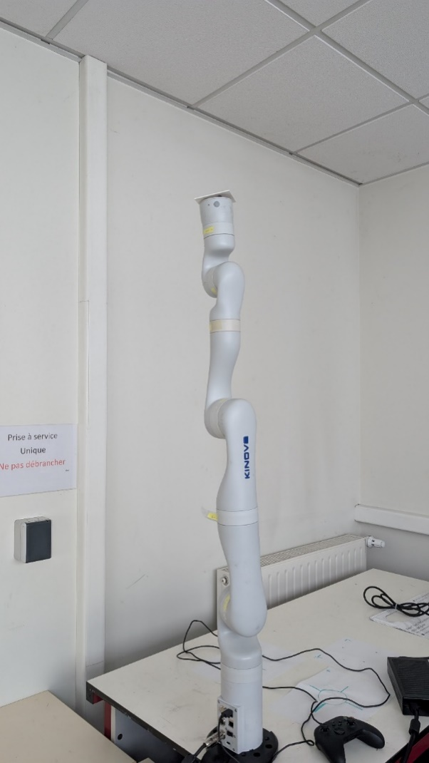
Figure 11: Kinova Gen3 manipulator

Central computing unit
In plan A of this project the developed software is supposed to be installed on an external computing unit. This can for example be a Raspberry Pi or Jetson Nano (Nvidia, n.d.), when this was tried the discovery was made that the robot drivers for the Kinova Gen3 aren’t developed for an ARM processor. This is the architecture that most of the small form factor computers run on. Therefore, the decision was made to post pone this part of the project for a later group.
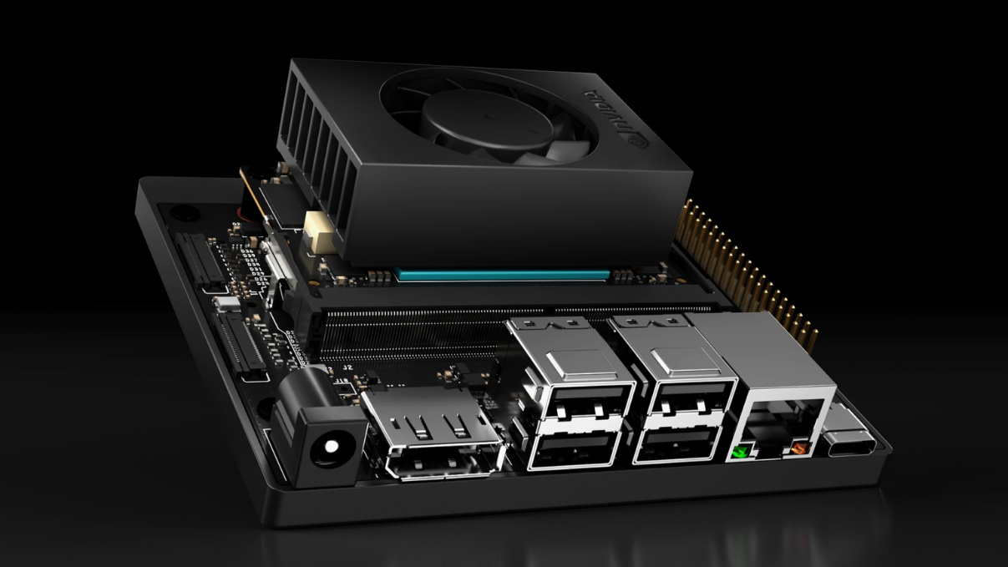
Figure 12: Nvidia Jetson Nano (Sheshadri, 2021)

Software study
This subsection provides an overview of all software tools required to develop, simulate, and operate the integrated robotic system. It begins by listing each software component and its version, establishing the foundation of the software environment used throughout the project, see Table 14. Following this inventory, the subsection describes the purpose and functionality of each tool: Ubuntu as the operating system, ROS2 as the communication framework, Gazebo for physics-based simulation, RViz2 and MoveIt2 for visualization and motion planning, and the Clearpath and Kortex libraries for robot-specific interfaces. The study concludes with a UML Deployment Diagram that illustrates how these software components are distributed across the hardware platforms and how they interact within the ROS2 ecosystem. Together, these elements define the software architecture upon which the system development and integration phases are built.
Table 14: Used software
Nr. | Name | Version | Type of software
1 | Ubuntu | 24.04 | Operating System
2 | ROS2 | Jazzy | Middleware communication between applications
3 | Gazebo Harmonic | 8.10.0 | Physics simulation of robots
4 | RViz2 | 14.1.17 | Visual representation of robot state
5 | MoveIt2 | N.A. | Plugin for RViz2, used for motion planning
6 | Clearpath libraries | N.A. | Ridgeback + Kinova Gen3 simulation packages
7 | Kortex Drivers | 0.2.3 | Kinova Gen3 driver for robot arm

During this phase the OS and applications were installed on all the machines. The newest version of Ubuntu was installed first in a virtual machine. Sadly, it was soon discovered that this method had problems because of the limited assigned hardware and communication with physical machines. Furthermore, the installation of the original ROS2 version, ROS2 Rolling, gave problems with stability.
That is why the switch to ROS2 Jazzy was made. In the end all the computers were prepared with Ubuntu 24.04 and ROS2 Jazzy (Open Robotics, sd). During implementation of all the necessary software for the project multiple problems where found which can be found in Appendix 7.1 reference R3.
In the end both robots where simulated and the Kinova arm made physically functional. For the latter the original documentation (Kinova Robotics, 2025) was used. This had the Kinova robot in RViz and gave control through MoveIt. The Ridgeback was then simulated in Gazebo using the opensource Clearpath libraries (Clearpath robotics, n.d.). This documentation also has a tutorial to combine the Kinova Gen3 with a different mobile robot from Clearpath. Using these tutorials a combined simulation of Ridgeback and Kinova Gen3 was made possible, which can be seen in Figure 13.
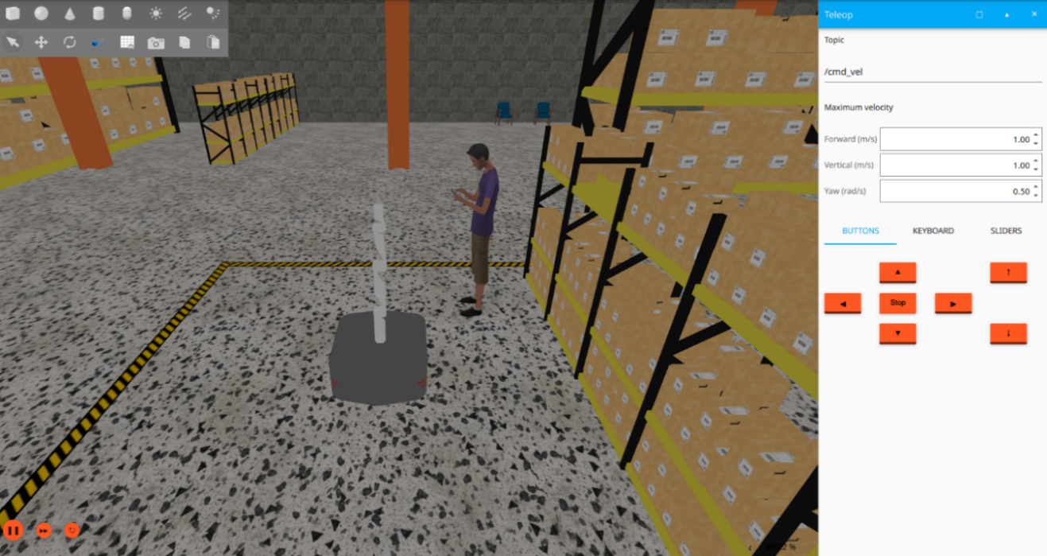
Figure 13: The simulation in Gazebo, simulated Ridgeback and the Kinova Gen3

Introduction of the used Software
- Ubuntu
Ubuntu is an open source operating system that is used on the main laptops, all the other software programs, like gazebo, are installed on here as applications (Canonical Ltd, sd). The newest released version of Ubuntu was used during this project, which in this case is 24.04 as can be seen in Table 14.

Figure 14: Ubuntu logo and code name
- ROS2
ROS2 is the successor to ROS, often called ROS1. It provides a middleware layer that facilitates communication between different parts of a robotic system, for example: sensors, actuators, and computing units. Unlike ROS1, ROS2 is designed with improved support for real-time computing, enhanced security, and cross-platform compatibility, allowing deployment on Linux, Windows, and macOS. ROS2 exists of multiple distribution, each of which serves their own purpose and is made for a separate Ubuntu release. Except for Rolling Ridley, this version is used for development and was too unstable to use during this project.

Table 15: ROS2 versions
Name | Logo | Date | Ubuntu version
Rolling Ridley |  | Release:  23-05-2020  End of Life:  N.A. | varied
Jazzy Jalisco |  | Release:  23-05-2025  End of Life:  05-2029 | 24.04
Humble Hawksbill |  | Release:  23-05-2022  End of Life:  05-2027 | 22.04

The way ROS works is with nodes and topics where nodes are the computing parts and topics the pipeline used for communication. Each node is used for a specific task and can publish to one or more topics to update them, for example the state of robot. A node can also be subscribed to one or more topics. By subscribing to it the node gets the latest available data and can react as needed.

- Gazebo
Gazebo is a 3D robotics simulation tool that provides a realistic visualization of environments, including high-quality lighting, shadows, and structures.
Gazebo use physics engines to simulate gravity, inertia, friction and collisions. This allows to simulate real-world dynamics between the robot and its environment. It is well integrated with ROS 2, allowing the exact same control code and topics used in simulation to be transferred to the real robot without modification – connecting their movements, states (Gazebosim, sd).
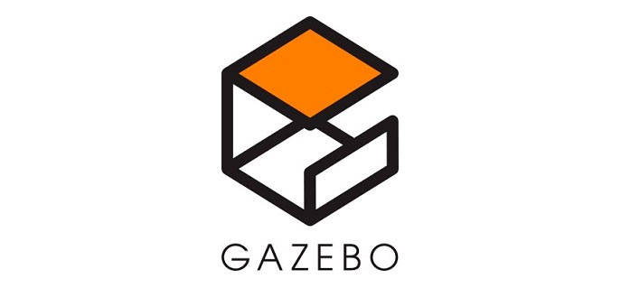
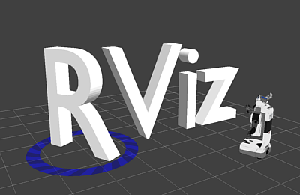
Figure 15: RViz2 Logo
Figure : Gazebo Harmonic Logo
- RViz2
RViz is one of the standard GUI tools provided by ROS. It allows to visualize robot sensor data (e.g. camera, lidar, radar), robot models, joint states, and system status in real-time via ROS topics. It’s widely used for debugging and is a common entry point for ROS newcomers.
- MoveIt
A motion planning, manipulation, and kinematics framework for ROS. MoveIt integrates directly with RViz as the motion planning plugin, enabling interactive control, visualization, and execution of robot motions (PickNic Robotics, sd).
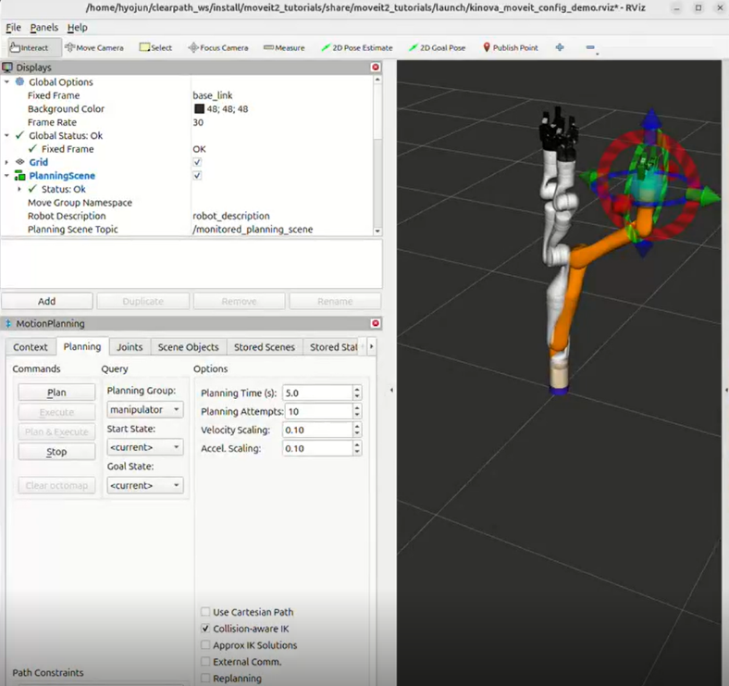
Figure 17: RViz application with MoveIt plugin for motion planning
- Clearpath Libraries
The Clearpath libraries are used in this project as backbone for the simulation. These libraries have everything form 3d models to drivers for the ridgeback robot. The files are open available to everyone, and need be used to simulate Clearpath robots, in this case that is the ridgeback. The company has experience with manipulators on their mobile platforms and has therefore integrated multiple popular manipulator arms in their simulation. The Kinova Gen3 is one of these, that’s why these libraries have a 3d model and easy setup guide for simulating the Ridgeback and Kinova together (Clearpath robotics, n.d.).

Figure 18: Clearpath Robotics logo
- Kortex Driver
Kortex drivers are official’s Kinova library for controlling gen3 manipulator. It provides APIs for trajectory planning, sensors and real-time control of Kinova. In this case Kortex driver was used to control real Kinova arm, execute trajectories from MoveIt and synchronize movements with the simulation through mirror-bridge node.

Figure 19: Kinova Logo

Software deployment architecture
The deployment diagram shows how software components are mapped onto the hardware infrastructure. It also shows what software application need what application to function. For example, the RViz2 application running on a laptop needs MoveIt2 to calculate certain movements.
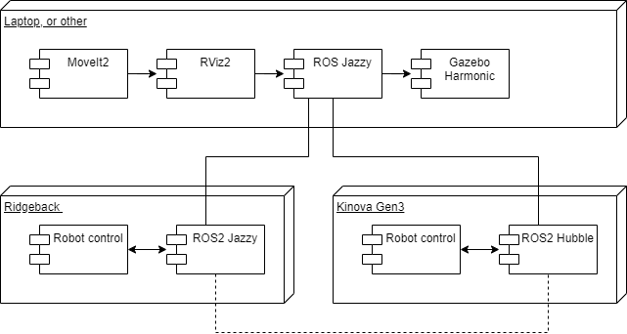
Figure 20: UML Deployment diagram

Development of the communication bridge between simulated and physical systems
During the development phase, a major issue appeared when integrating the Kinova Gen3 arm with the simulated Ridgeback platform. Although MoveIt2 successfully published planned trajectories to the physical Kinova Gen3, the same trajectories were not received by the simulated arm attached to the Ridgeback. Initial debugging showed that both systems used a similar joint_trajectory interface, but with different namespaces.
MoveIt2 always publishes its output to /display_planned_path, and internally this includes a joint trajectory message. The physical Kinova Gen3 controller listens to /joint_trajectory_controller/…, but the Ridgeback-mounted Kinova Gen3 simulation uses a separate namespace controller topic, namely: /r100_0000/arm_0_joint_trajectory_controller/…. This is where the core of the miscommunication lies. Additionally, the simulated robot requires joint names with the prefix arm_0_, while the physical Kinova Gen3 uses joint names without a prefix. This additional difference made it impossible to directly share commands between both robots.
To solve this, a custom ROS2 node called mirror_node was developed. The purpose of this node is to Receive trajectory commands from the two possible sources: Moveit2 motions via /display_planned_path and Terminal commands, to then Normalize and forward the trajectory to both robots simultaneously, ensuring consistent behaviour across simulation and real hardware.
The node performs automatic joint-name normalization. For simulation, names are converted to the arm_0_ format, while the physical robot version removes this prefix again. After normalization, the node publishes the same message to the two topics: /r100_0000/arm_0_joint_trajectory_controller/… and /joint_trajectory_controller/… This ensures that a single command from Moveit2 triggers motion in both the simulated and real Kinova Gen3 arms. Would the need arise to control 2 arms on 1 Ridgeback than the node will need to be edited, but this is outside of the scope for this project. The functioning of the node can be seen in Figure 21: UML State diagram.
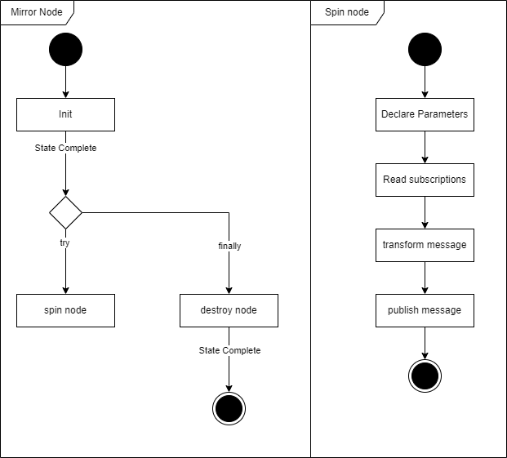
Figure 21: UML State diagram
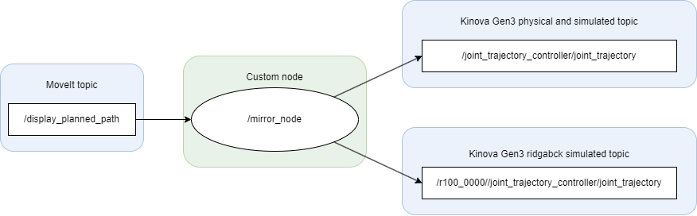
Figure 22: Schematic overview developed ROS2 structure
The final version of the node includes input validation, logging, and support for multiple trajectory points. Figure 22 represents a schematic overview of how MoveIt, the mirror_node, and the two robot controllers interact within the ROS2 network. For a complete overview look in Appendix 5: Ros2 RQT Graph. To finally result in the code, as sampled in Figure 23.
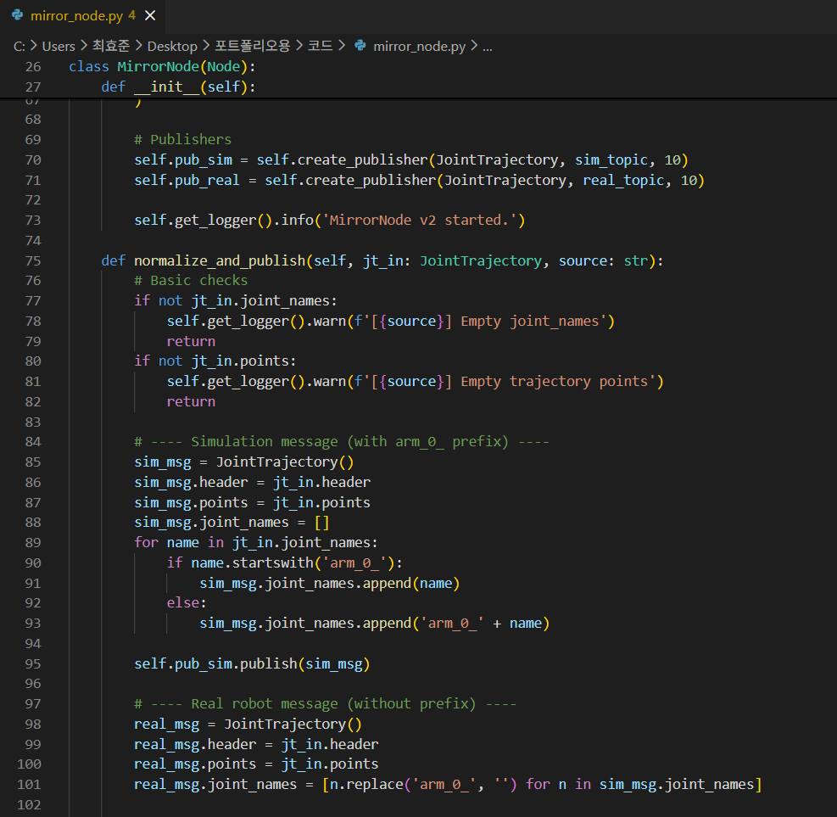
Figure 23: Mirror_node code sample

Testing and validation
The testing and validation phase aimed to verify the correctness, stability, and usability of the developed ROS2-based communication framework across both the simulated environment and the physical Kinova Gen3 robot. Validation activities were carried out iteratively throughout the project, with each major software update followed by dedicated test sessions to ensure that the system behaved as expected and that previously resolved issues did not reappear. Testing began with isolated verification of individual components, such as confirming that the Kinova Gen3 could be controlled reliably through MoveIt2 and that the Ridgeback simulation responded to manual driving commands in Gazebo. Once the individual systems were stable, the focus shifted toward evaluating the integrated architecture.
A primary validation objective was to confirm the proper functioning of the mirror_node, which acts as the communication bridge between simulation and physical hardware. Tests examined the node’s ability to correctly reinterpret joint names, normalize namespaces, and forward trajectories simultaneously to both the simulated and real arm. This required generating complicated motion trajectories which were also used for a demo video.
Finally, hardware-related validation was attempted using the Nvidia Jetson microcontroller as a potential central computing unit. Although this component could not be fully integrated due to incompatible Kortex drivers on ARM architecture. These attempts confirmed the limitations and were added to the recommendations for future teams, which can be found in section 6.2. In section 5.2 the requirements are listen and which have been met and which haven’t.

User documentation and operational guidelines
This subsection presents the documentation developed to support future users and project teams in installing, operating, and extending the system. The user guidelines consist of two complementary documents: a User Manual, which provides step-by-step instructions for setting up the software environment, running the simulation, and operating the physical Kinova Gen3 robot; and a Technical Report, which records the encountered issues, implementation details, and solutions identified throughout the project. Together, these resources ensure that the developed ROS2 architecture is reproducible, transparent, and accessible for continued development beyond the scope of this project.

User Manual and System Setup Guide
During this phase, the team created the complete documentation required for future users and development teams. The goal of this phase was to a produce clear, structured, and reproducible manual that explain how to install, configure, and operate both the simulation environment and the physical robot. The manual was written based on the finalized software architecture and verified through multiple test runs. See Appendix 7.1 reference R3.
The primary output of this phase is the Setup Guide, which contains:
- System requirements and prerequisites
- Installation procedures for ROS2 Jazzy and required dependencies
- Simulation tool installation
- Workspace structure and package description
- Step-by-step instructions for building and running the simulation
- Instructions for connecting and operating the physical Kinova Gen3
- Appendix with required APT packages and references
This guide ensures that future teams can reproduce the software environment without additional support.
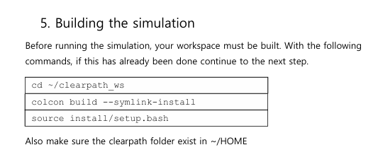
Figure 24: Example of user guideline

Technical documentation of software architecture and issues
This document, see Appendix 7.1 reference R3, serves as a complementary document to the User Manual, providing an in-depth record of the technical challenges, decisions, and solutions encountered throughout the development of the integrated robotic system. While the manual focuses on operational instructions, this report documents the underlying reasoning and implementation details that shaped the final architecture. It includes a systematic description of the software installation process, configuration decisions, and compatibility issues, particularly those arising from differences between ROS2 distributions, simulation engines, and hardware platforms. Special attention is given to the development of the custom mirror_node, explaining the namespace inconsistencies, joint-name mismatches, and message-handling problems that motivated its creation.
In addition, the Technical Report compiles all significant troubleshooting procedures carried out during the project. This includes unexpected behaviour observed during simulation, instability caused by ROS2 Rolling, communication losses, plugin failures in Gazebo, and the limitations encountered when testing the Nvidia Jetson platform with Kortex drivers. For each issue, the report provides both the diagnostic steps used to identify the root cause and the corrective actions applied to reach a stable solution or, when unresolved, recommendations for future work. By documenting these experiences in detail, the Technical Report ensures that future EPS teams can build on the existing foundation, avoid repeating known pitfalls, and efficiently continue the development of a fully integrated mobile manipulator.

Monitoring
This section presents the monitoring activities conducted throughout the project and explains how progress, workload distribution, risks, and meeting outcomes were systematically tracked. The monitoring process served as a continuous assessment mechanism, enabling the team to verify adherence to the project plan, identify emerging challenges at an early stage, and maintain clear documentation of individual and collective contributions. By structuring and reviewing these monitored elements regularly, the team ensured coherent progression toward milestones and maintained alignment with both technical and managerial objectives.

Workload monitoring
During the entire project a logbook has been made and kept up to date with the hours everybody has made. From this logbook graphs have been made to show the workload compared to the estimation. The table for the workload estimation can be found in Table 13 and Table 12.
In the graphs listed in Figure 26: Actual workload of the project Figure 26 and Figure 25 show the comparison of the actual workload and the estimated workload. There can be seen that the estimation came close to the actual workload. There are no big deviations in the actual workload and the estimated workload. Everybody has done the part that was given and estimated and finished that in the given time.
Figure 25: Estimated workload of the project
Figure 26: Actual workload of the project

Besides the total workload a graph has been made for the workload per category that was made in the logbook. These categories are made for clarity and globalization of the logbook. In this graph it is shown how much time has been spent working it and its percentage. See Figure 27 or the graph and its contents.
Figure 27: Total time spent per category

Evaluation of Project Requirements
This section presents the final verification of the project requirements, as summarized in Table 16. The table evaluates each requirement defined at the beginning of the project and indicates whether it was met, not met, or partially achieved, accompanied by brief remarks that justify the outcome. This verification highlights the extent to which the project objectives (both technical and managerial) were fulfilled within the constraints encountered during the semester. A key insight from this assessment is that all core requirements associated with Plan B were successfully completed, ensuring a functional and validated simulation environment and physical control of the Kinova Gen3. Conversely, the requirements linked to Plan A, notably those involving the Ridgeback’s physical testing, the Pioneer LX integration, and the use of a central computing unit, could not be met due to hardware limitations and compatibility issues. Overall, the results reflect a coherent and achievable implementation aligned with the adjusted project scope while providing a clear foundation for future continuation.
Table 16: Requirements qualification
Nr. | Title of requirements | Qualification | Remark
1.1 | Integrating existing code | Met | Existing code modified and integrated.
1.2 | The system of ROS will be used | Met | All system structures rely on ROS 2 Jazzy.
1.3 | The simulation contains 2 separate robots. | Met | Simulation contains 2 separate robots.
1.4 | Compatibility research ROS distributions. | Met | ROS Rolling proved unstable, Jazzy selected as final distro.
1.5 | Real world physical testing Kinova Gen3 manipulator arm | Met | Physical Kinova tested and controlled through ROS2 and MoveIt.
1.6 | Typical use case for proof of integration | Met | Typical use case movement integrated (move together).
1.7 | Simulation environment for testing and validation | Met | Gazebo simulation build.
1.8 | Extra robot for real world validation with the Pioneer LX | Not met | Pioneer not integrated due to schedule constraints.
1.9 | Physical testing Ridgeback mobile robot. | Not met | Battery not available.
1.10 | Central computing unit for robot integration. | Not met | Compatibility issues with the computing unit and the ROS destitutions needed for running the robots

Milestones Tracking and Completion Analysis
This section provides an overview of the project’s key milestones and compares the planned completion dates with the actual progress achieved throughout the semester. Table 17: Milestone monitoring summarizes each milestone, its planned execution date, and the corresponding date on which it was effectively completed.
Table 17: Milestone monitoring
Nr. | Set date | Milestone | Actual date
M1 | 01/09/2025 | Project start | 01/01/2025
M2 | 09/10/2025 | Submission of intermediate report and technical requirements | 09/10/2025
M3 | 16/10/2025 | Intermediate presentation | 16/10/2025
M4 | 14/11/2025 | Software simulation for Kinova | 17/10/2025
M5 | 17/11/2025 | Physical testing for Kinova | 07/11/2025
M6 | 21/11/2025 | Software simulation for Ridgeback | 24/10/2025
M7 | 11/12/2025 | Combining both robots in software simulation | 28/11/2025
M8 | 11/12/2025 | Submission of final report | 11/12/2025
M9 | 18/12/2025 | Final presentation | 18/12/2025

As shown in Table 17 nearly all milestones were achieved ahead of their scheduled dates, demonstrating efficient task execution and effective internal coordination throughout the project. However, reaching a milestone did not immediately signify full completion of the corresponding work package. Following each milestone, substantial time was devoted to documenting the implemented solutions, validating their stability, and ensuring that all outputs conformed to the required technical and reporting standards. This post-milestone consolidation phase often extended beyond the initial target dates, as thorough verification and high-quality documentation were essential for delivering a reliable and reproducible final system. Consequently, while the technical objectives were met earlier than expected, the overall milestone periods were prolonged due to the additional efforts required to refine, validate, and formalize the results.

Observed Risks and Corrective Measures
During this project some medium and hight level risks that were noted in the intermediate report, have been encountered. None of them caused big problems but some thoughts had to be made to work around them.
- Sickness: During the whole project some members of the project and supervisor got sick. This resulted in the movement of a meeting.
- Schedule conflicts: Sometimes, when planning a meeting with one of our supervisors some schedule conflicts were encountered. To try to solve this, a regular weekly meeting was set up with our technical supervisor.
- ROS2 rolling instability: As predicted was ROS2 rolling not stable. This resulted in changing to ROS2 jazzy.

Conclusions and discussion
This chapter presents summary and reflection on the project's outcomes. It analyses and outlines recommendations for future team who may continue project.

Conclusion of the project
Throughout this project, the team successfully developed, tested, and documented a functional communication framework enabling collaboration between the Kinova Gen3 robotic arm and the Ridgeback mobile robot within a ROS2-based environment. Despite the physical limitations caused by the non-operational Ridgeback and compatibility issues with ARM-based Jetson Nano, the objectives defined in Plan B were fully achieved. A complete simulation of both robots validated physical control of the Kinova Gen3, and the creation of a custom trajectory-mirroring ROS2 node demonstrate the technical feasibility of integrating both platforms into a unified mobile manipulator system.
The project also highlighted the importance of adaptability: several risks materialized, including software instability, hardware malfunctions, and scheduling conflicts. These challenges were consistently addressed through teamwork, structured planning, and close communication with supervisors. The workload distribution remained accurate to initial estimates, and the monitoring process ensured steady progress toward each milestone.
In conclusion, the project provides a solid foundation for future development of a fully functional mobile manipulator. All deliverables technical, managerial, and documentation have been completed, and the produced simulation environment, manuals, and software architecture offer continuity for future EPS teams. With additional hardware support and sensor integration, the system can be further extended to achieve full autonomous navigation and advanced collaborative capabilities.

Future work
For the best continuation of this project a few recommendations are made. It is also good to know that all the documentation and software made and used in this project have been saved on a USB-stick which was handed to Thierry Louge, the technical supervisor. In here a manual can be found on how to use the software.
The first recommendation is for hardware. As previously mentioned, a high-performance computer is recommended to ensure stable and efficient simulation, especially for Gazebo and RViz.
The second recommendation is to connect a LiDAR sensor. During this project, several attempts were made to integrate a LiDAR sensor in Gazebo, but the simulation crashed immediately due to sensor plugin errors and segmentation faults. Future teams are encouraged to investigate this issue and ensure stable LiDAR integration inside Gazebo.
The third recommendation is to integrate Nav2. Although Nav2 was successfully brought up in the simulation, the navigation accuracy was very low. The main reason for this was the absence of a LiDAR sensor. Without proper scan data, the localization system could not estimate the robot’s position accurately, causing the robot to deviate from its planned path. Future teams are encouraged to add a functioning LiDAR setup so that Nav2 can operate with reliable sensor input and achieve stable navigation performance.
The final recommendation is to consider compatibility limitations. During the project, it was discovered that the Kortex driver does not support ARM64 architecture, which prevented the use of the Jetson platform for controlling the Kinova Gen3. Future teams should keep this limitation in mind when selecting hardware and consider alternative platforms that are fully compatible with Kortex driver.

Appendixes

Appendix 1: References
Table 18: Referenced documentation
Nr. | Document name | Title | Version
R1 | Project Requirements_V2 – BOB.docx | Project Requirements | 2
R2 | 250829-MCF 61S LGP | ECOSYSPOR
R3 | Technical Report - BOB – V1.0 | Technical report | 1
R4 | Setup Guide (EPS) | Setup Guide
R5
R6
R7
R8
R9

Appendix 2: Bibliography
Canonical Ltd. (n.d.). Home. Retrieved from ubuntu.com: https://ubuntu.com/
Clearpath robotics. (n.d.). Clearpath robotics documentation. Retrieved December 2025, from https://docs.clearpathrobotics.com/docs_robots/indoor_robots/ridgeback/user_manual_ridgeback/
Clearpath Robotics. (n.d.). Ridgeback indoor robot platform. Retrieved from clearpathrobotics.com: https://clearpathrobotics.com/ridgeback-indoor-robot-platform/
davetcoleman. (2018, September 17). rqt_graph. Retrieved from ros.org: https://wiki.ros.org/rqt_graph
European Project Semester. (n.d.). Providers. Retrieved September 11, 2025, from europeanprojectsemester.eu: https://europeanprojectsemester.eu/providers
Gazebosim. (n.d.). docs. Retrieved from gazebosim.org: https://gazebosim.org/docs/latest/getstarted/
Kinova Robotics. (2025, December 10). Kinova Gen3 Github. Retrieved December 10, 2025, from https://github.com/Kinovarobotics/
Kinova Robotics. (n.d.). gen3 robots. Retrieved from Kinovarobotics.com: https://www.kinovarobotics.com/product/gen3-robots
Nvidia. (n.d.). Jetson Nano. Retrieved from developer.nvidia.com: https://developer.nvidia.com/embedded/jetson-nano
Open Robotics. (n.d.). Basic Concepts. Retrieved from docs.ros.org: https://docs.ros.org/en/jazzy/Concepts/Basic.html
Open Robotics. (n.d.). home. Retrieved from ros.org: https://www.ros.org/blog/why-ros/
PickNic Robotics. (n.d.). Home. Retrieved from moveit.ai: https://moveit.ai/
Sheshadri, L. S. (2021, March 21). Technical Blog. Retrieved December 10, 2025, from NVIDIA Developer: https://developer.nvidia.com/blog/develop-ai-powered-robots-smart-vision-systems-and-more-with-nvidia-jetson-orin-nano-developer-kit/
Wittwer, J. (2024, oktober 29). Risk Assessment Matrix Template. Retrieved from Vertex42.com: https://www.vertex42.com/ExcelTemplates/risk-assessment-matrix.html

Appendix 3: WBS
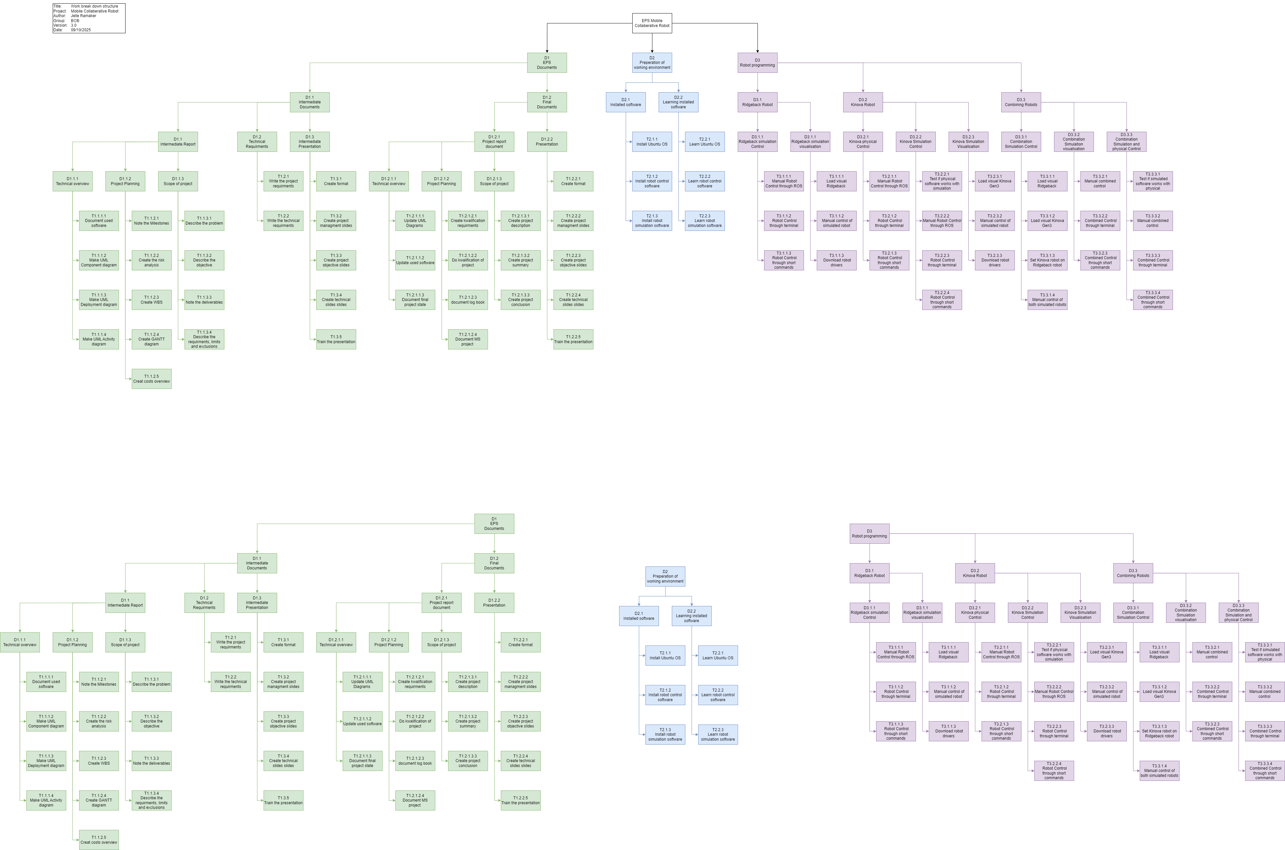
Figure 28: WBS EPS documents

Figure 29: WBS Technical part

Figure 30: WBS programs part

Appendix 4: Gantt Chart
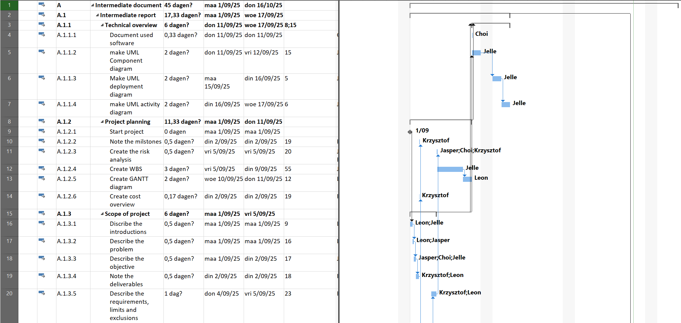
Figure 31: Gantt chart part 1
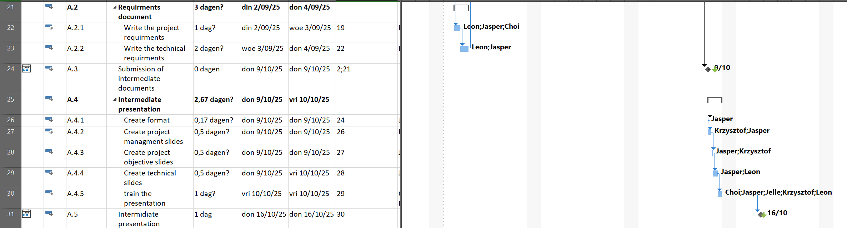
Figure 32: Gantt chart part 2

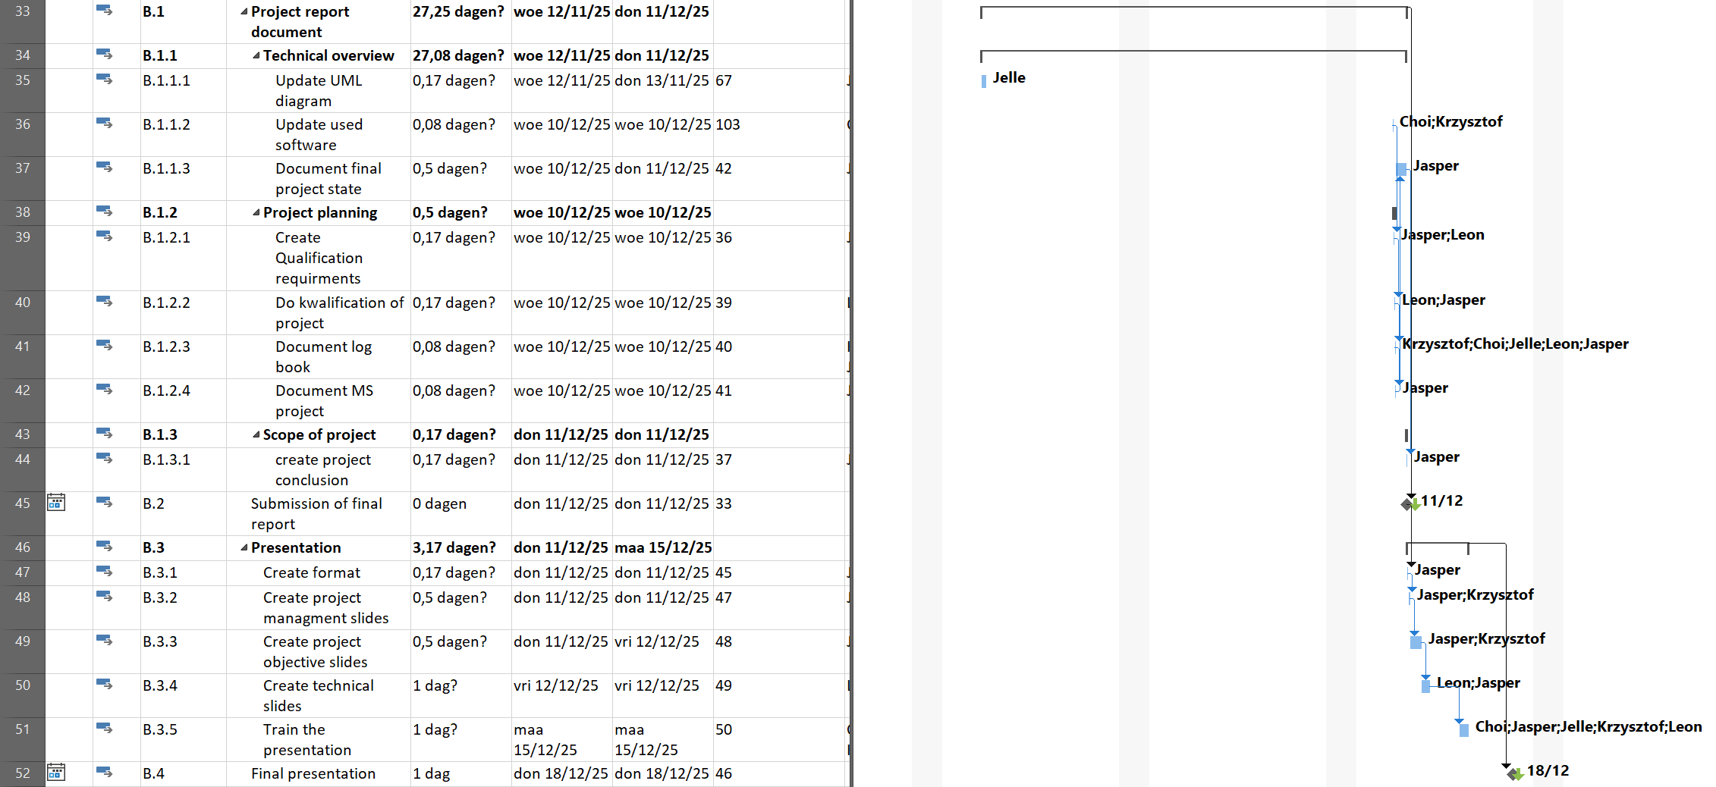
Figure 33: Gantt chart part 3
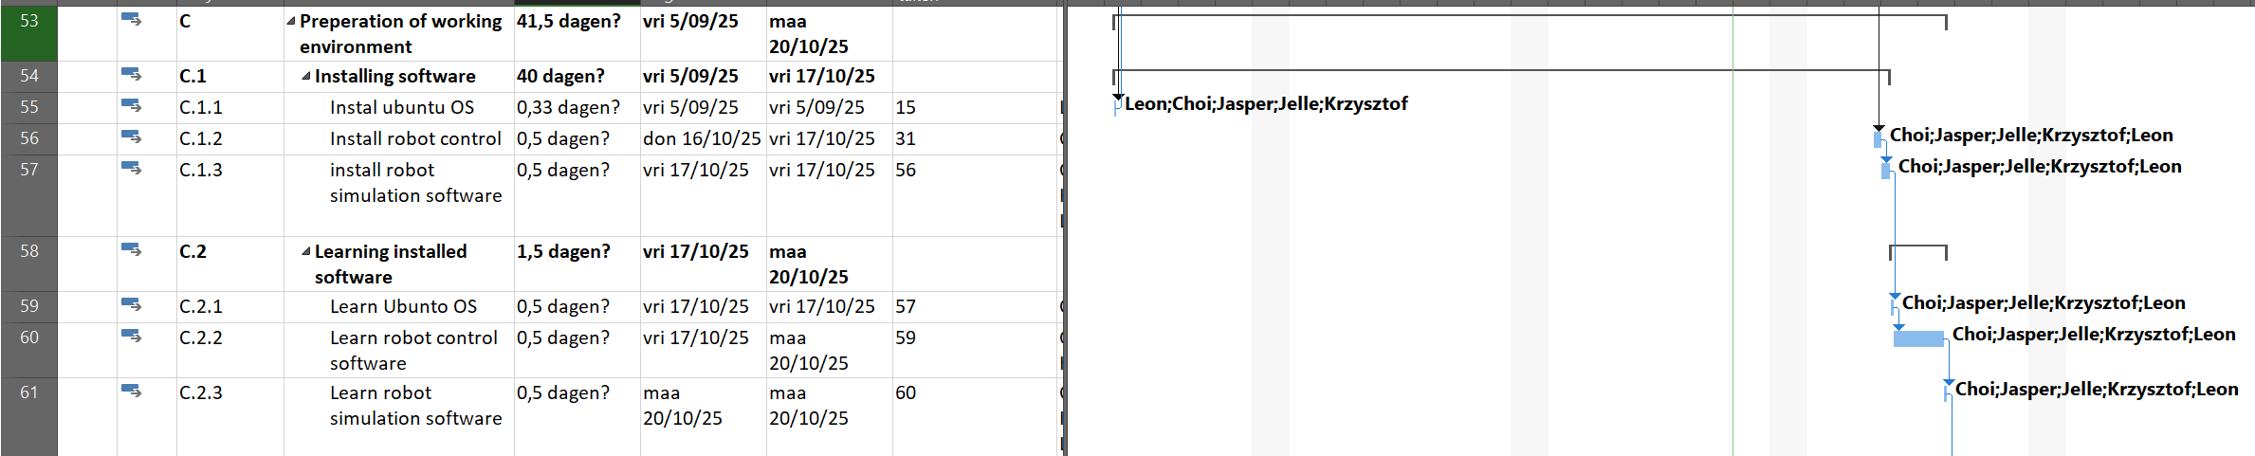
Figure 34: Gantt chart part 4

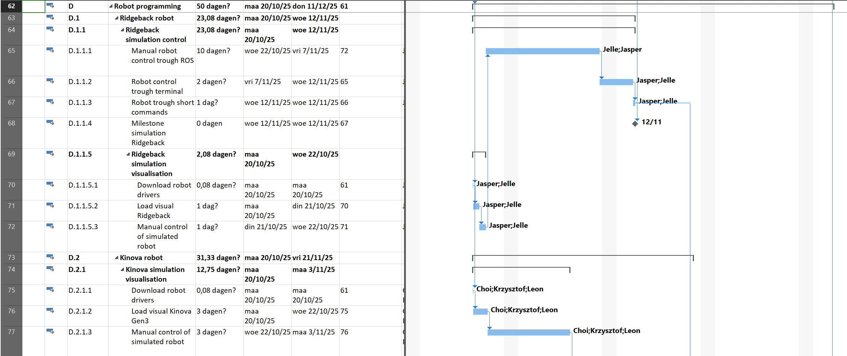
Figure 35: Gantt chart part 5
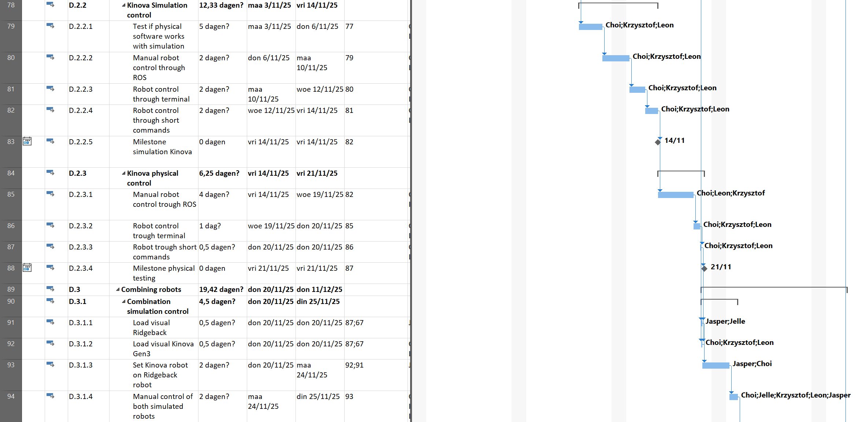
Figure 36: Gantt chart part 6

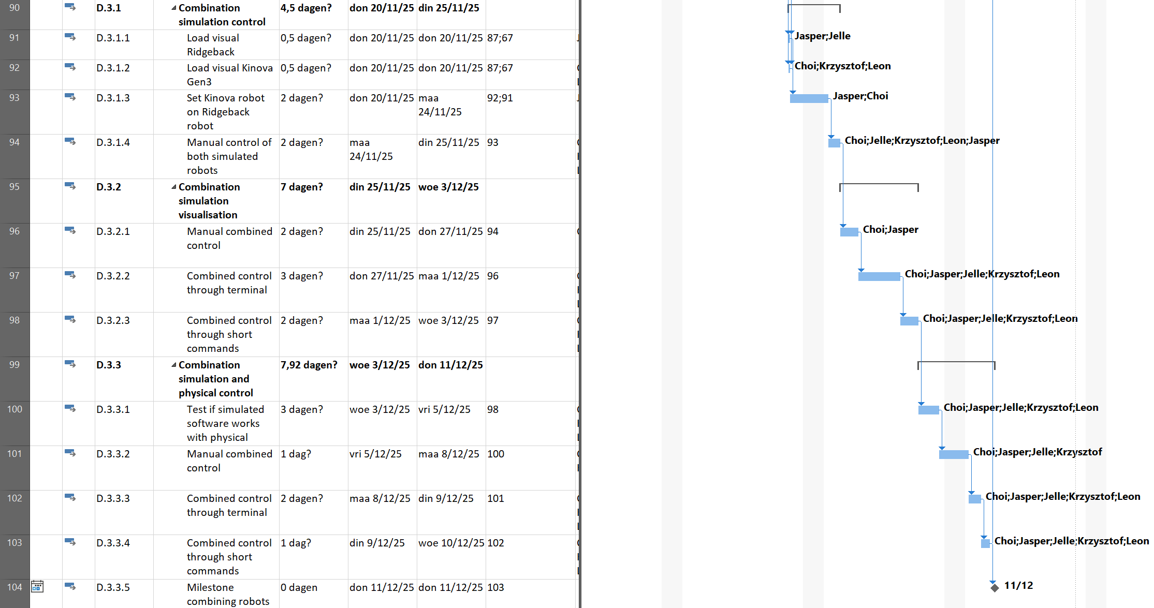
Figure 37: Gantt chard part 7

Appendix 5: Ros2 RQT Graph
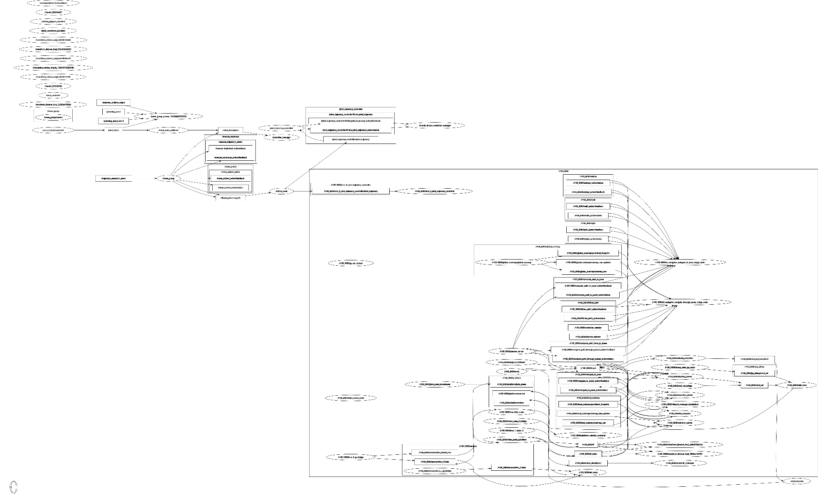
Figure 38: ROS2 RQT Graph (davetcoleman, 2018)

Appendix 6: Total timetables
Table 19: Total time spend per category of work
Who | Project management | Project documentation | Software learning | Software testing | Meetings | Total time
Choi "C" | 0,00 | 27,54 | 122,40 | 137,70 | 18,36 | 306,00
Krzysztof "K" | 26,36 | 131,82 | 79,09 | 26,36 | 18,36 | 282,00
Leon "L" | 25,66 | 128,32 | 76,99 | 25,66 | 18,36 | 275,00
Jelle "JR" | 0,00 | 70,91 | 99,27 | 113,46 | 18,36 | 302,00
Jasper "JB" | 75,19 | 150,38 | 10,03 | 15,04 | 18,36 | 269,00
Total per | 127,22 | 508,97 | 387,78 | 318,22 | 91,80 | 1434,00

